Real Number :Rational & Irrational

Pralay Poria
Asst. Professor Of Mathematics
Sabang Sajanikanta Mahavidyalaya

A number is a mathematical object used in counting and measuring. A notational symbol which represents a number is called a numeral, but in common usage the word number is used for both the abstract object and the symbol, as well as for the word for the number. In mathematics, the definition of number has been extended over the years to include such numbers as 0, negative numbers, rational numbers, irrational numbers, and complex numbers.
If we think about it, mathematics is all about a straight line. That’s all it is. That straight line is called “THE NUMBER LINE” which will refer to as the “LINE”.
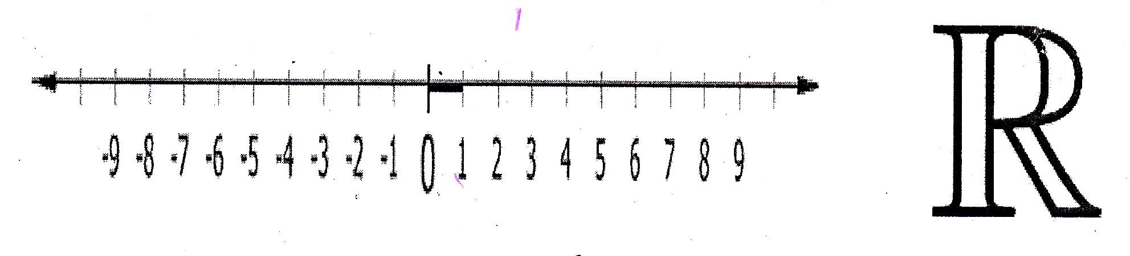 If a number can be located on a point on the line, that number is called a “REAL NUMBER”. All real numbers are points on the line. Its absolute value will name the distance of that point from zero (0). The real numbers therefore are the numbers we need for measuring. In mathematics, all “RATIONAL” and “IRRATIONAL” numbers are points on the line. Thus, the set of all real numbers consists of rational and irrational numbers.

Rational Numbers

A rational number is a nameable number, in the sense that we can name it according to the standard way of naming whole numbers, fractions and mixed numbers. “One hundred thirty nine”; “four thousand three hundred seventy two” and so on.
A number, which can be written as a simple fraction form is called rational number.
That is, a rational number is a number that can be written in the form p/q, where p and q are integers and q is not equal to zero.
For example: 2, 3/7, -8 , -5/8 , 0 etc.
When p and q are positive, then we can name their ratio as “positive rational” number.

Decimal representation of rational numbers

Any rational number is either a Terminating Decimal or a Recurring Decimal (also called Periodic Decimal). From arithmetic, we know that we can write a decimal as a fraction. The rational fraction p/q can be expressed as decimals by long division.
If the denominator q contains no prime factor other than 2 or 5, the decimal for p/q will terminate.
For example: 2/5=0.4 ½ =0.5, 6/5=1.2, 7/2=3.5 etc.
Otherwise, the decimal for p/q will be recurring or periodic i.e., a group of digits will repeat without end. After at most q-1 divisions, a remainder will appear for a second time and thereafter all remainders will repeat again infinitely in the same order.
For example: 4/7=0.5712857 142857 142857 142857 142857…….
5/9=0.555555555555555555555555555555555…….
3/11=0.27272727272727272727272727272727….etc.
Mathematically, a decimal number p.a₁ a₂ a₃……is said to be periodic decimal or recurring decimal if there exist natural number m and k such that a_{n}=a_{n+m} for all n ≥k, where m denote the period of decimal and period starts from the k^{th} stage.
[In above example, 4/7=0.57142857142857142857142857…… the period of the decimal is m=6 and the period starts from k=2th stage. So, a₂ =a_{2+6,} a₃ =a₃₊₆ and so on.]
Mathematically, again, a decimal number p.a₁a₂a₃……is said to be terminating decimal if there exist a natural number k such that a_{n} =0 for all n ≥k. A terminating decimal can be regarded as a periodic decimal with the repeating block 0.

Irrational Numbers
In mathematics, an irrational number is any real number which cannot be expressed as a fraction or ratio p/q, where p and q are integers and q#0. That is an irrational number is a number that cannot be written as a simple fraction and the decimal goes on forever without repeating. More precisely, a non-terminating or non-recurring real numbers are irrational numbers. As a consequence of cantor’s proof that the real number s are uncountable (and the rationales countable) it follows that almost all real numbers are irrational.

For example: √2=1.4142135623730950488016887242097……..(and more….)
This is no pattern to the decimals, and we cannot write down a simple fraction that equals to √2.
History of Irrational number

In Mathematics, the concept of irrational number was implicitly accepted by Indian mathematicians, since the 7th century BC, when Manava (c.750-690 BC) believed that the square root of certain numbers such as 2, 3, 5…… etc could not be exactly determined.
Apparently Hippasus (one of Pythagoras’ students) discovered irrational numbers when trying to represent √2 as a fraction (using geometry). Instead he proved that you couldn’t write √2 as a fraction and therefore it was irrational.
However, Pythagoras could not accept the existence of irrational numbers, because he believed that all numbers had perfect values. But he could not disprove Hippasus’ “Irrational Numbers” and so Hippasus was thrown overboard and drowned.
Greek Mathematicians termed this ratio of incommensurable magnitudes alogos, or inexpressible. Theodorus of Cyrene proved the irrationality of the surds of whole number up to 17, but stopped there probably because the algebra he used couldn’t be applied to the square roof of 17. It wasn’t until Eudoxus developed a theory of proportion that took into account irrational as well as rational ration that a strong mathematical foundation of irrational numbers was created. Eudoxus theory enables the Greek mathematicians to make tremendous progress in geometry by supplying the necessary logical foundation for incompresurable ratios.
In the Middle ages, the development of algebra by Arab mathematicians allowed irrational numbers to be treated as “algebraic objects”. The Egyptian mathematician Abū Kāmil Shujā ibn Aslam (c.850-930) was first to accept irrational numbers as solutions to quadratic equations or as coefficients in an equation, often in the form of square roots, cube, roots and fourth roots. During the 14th to 16th centuries, Madhava of Sangamagrama and the Kerala School of astronomy and mathematics discovered the infinite series of several irrational number such as pi and certain irrational number of triconometric functions.
In Modern period, near about 17th century, imaginary number become a powerful tool in the hands of Abraham de Movire, and especially of Leonhard Euler. The completion of the theory of complex numbers in 19th century entailed the differentiation of irrationals into algebraic and transcendental numbers. Still now, we cannot go ahead successfully without any irrational numbers.

Famous Irrational Numbers

a)Square roots

The square root of 2 was first number to be proved irrational. Its numerical value truncated to 65 decimal places is..
√2=1.41421 35623 73095 04880 16887 24209 69807 85696 71875 37694 80731 76679 73799…….
It is not possible to express √2 exactly as a decimal. We could continue the approximation for as many decimal digits as we please by means of the algorithm, or method, for calculating each next digit; and again, the more decimal digits we calculate, the closer we will be to √2.
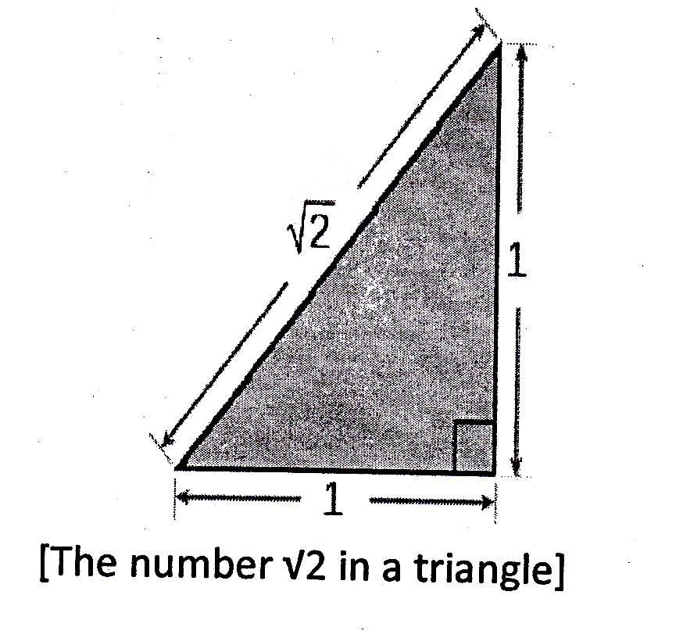
By recalling the Pythagorean theorem we can see that irrational numbers are necessary. For if the sides of an isosceles right triangle are called 1, then we will have 1²+1²=2, so that the hypotenuse is √2, which is a non-number. But, how can this be since we can measure the hypotenuse length with a ruler or scale and get definite answer? The length of hypotenuse is not becoming a number; it has an exact beginning and an exact ending point on the ruler. Obviously, the hypotenuse has a finite measurement. But √2 is not finite. There realy is a length that logically deserves √2, then √2 is a number.

History of √2 :

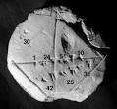
(Babylonian clay tablet YBC 7289 with annotations)
The Babylonian clay tablet YBC 7289 (c.1900-1600 BCE) gives an approximation of √2 as
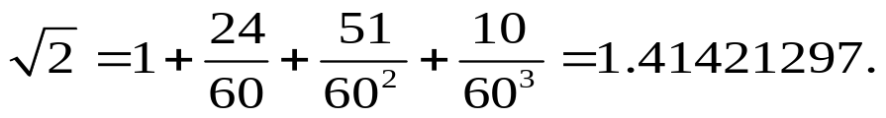
Which expresses √2 in the sexagesimal system. And which too accurate up to 5 decimal place.
Another early close approximation of √2 is given by Baudhayana (800-200 BC):
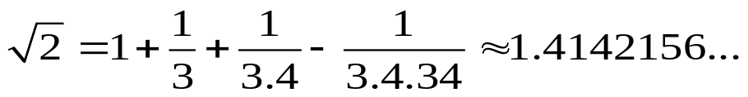
The formula is accurate up to five decimal places. We can arrive closer to √2 through successive iteration like as.
3/2=1.5
7/5=1.4 ( Upto 1 decimal place)
17/12=1.416666…. (Upto 2 decimal place)
41/29=1.4137931034482758620689655172414… (Upto 2 decimal place)
99/70=1.41428571428571428574142857142857... (Upto 4 decimal place)
239/169=1.4142011834319526627218934911243… (Upto 4 decimal place)
577/408=1.414215686274509803921568627451… (Upto 5 decimal place)
665857/470832=1.4142135623746899106262955788901… etc (Upto 7 decimal place)
Also, the number √2 has the following continued fraction representation.
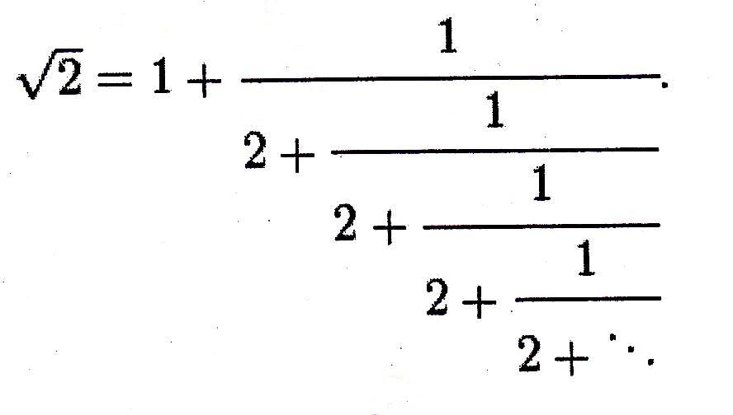
The value of √2 was calculated to 137, 438, 953, 444 decimal places by Yasumasa Kanada’s team in 1997.
In February 2006, Shigeu Kondo calculated 200,000,000,000 decimal places of √2 in 13 days and 14 hours using a 3.6 GHz PC with 16 GiB of memory.
In general, the square root of non perfect square numbers are irrational. Such as: √5, √11, √22, √80, √300, √2010 etc..
Therefore, if an integer is not an exact k^{th} power of another integer then its k^{th} root is irrational.
b) Logarithms

The numbers most easily proved to be irrational are certain logarithms. It is noted that, the natural logarithm of every integer ≥2 is an irrational number and that the decimal logarithm of any integer is irrational number unless it is a power of 10.
Theorem: The natural logarithm of every integer ≥2 is an irrational number.
Proof: If possible let, lnn=a/b is a rational number for some integers a and b and also assume that a, b >0. The above equation is equivalent to n^{b}=eª.
Since, a and b both are positive integers, it follows that e is the root of a polynomial with integer coefficients (with leading coefficient 1), namely, the polynomial xª-n^{b}. Hence e is an algebraic number; which is a contradiction.
Hence, the theorem is proved.
Remarks: It follows from the proof that for any base b which is a transcendental number the logarithm log_{b}^{n} of every integer n≥2 is an irrational number. (It is not always true that log_{b}^{n} is already irrational number for every integer if b is irrational number; for example, b=√2 and n=2)
Theorem: The decimal logarithm of every integer n is an irrational number unless n is a power of 10.
Proof: If possible let, log n=a/b is a rational number for some integers a and b and also assume that a,b >0.

The above equation is equivalent to n^{b}=10ª=2ª .5ª. Since n is an integer, then from the Fundamental Theorem of Arithmetic, it follows that n=2^{r}.5^{s} for some positive integers r and s.
Therefore, n^{b}=2^{rb}.5^{sb}
i.e., 2ª.5ª=2^{rb}. 5^{sb}
This implies that, rb=a and sb=a;
i.e., r=s
Hence, n=2^{r}.5^{r}=10^{r}; which is a contradiction.
Hence the theorem is proved.
Remarks: For any integer base b the logarithm log_{b}^{n} of every integer n is an irrational number unless n is a power of b.

c) Pi (or π)
π ( the first letter of Greek word) is a mathematical constant whose value is the ratio of any circle’s circumference to its diameter in Euclidean space.
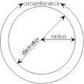
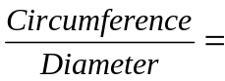 π 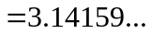
Also, π has the same value as the ration of a circle’s area to the square of its radius. The constant is π is also known as Archimedes Constant.

Rational Approximation of π:
Due to the transcendental nature of π, there are no closed form expressions for the number π in terms of algebraic numbers and functions. We also apply numerical calculation for the approximation of π. For some illustrations the fraction 22/7 is close enough to π. There are some good numerical approximations of π such as
22/7=3.1428571428571428571428571428571…..(Correct up to 2 decimal places)
333/106=3.1415094339622641509433962264151…..(Correct up to 4 decimal places)
355/113=3.1415929203539823008849557522124…..(Correct up to 6 decimal places)
52163/16604=3.1415923873765357745121657431944…(Correct up to 6 decimal places)
103993/33102=3.1415926530119026040722614947737….(Correct up to 9 decimal places). etc…
Decimal representation of π:
The Decimal representation of π with first 100 decimal places is:
π=3.14159265358979323846264338327950288419716939937510
58209749445923078164062862089986280348253421170679……
The decimal representation of π has been computed to more than a trillion (10¹²) digits. The digits of decimal representation of π are available on many web pages, and there is software for calculating the decimal representation of π to billion of digits on any personal computer. Its decimal representation does not repeat, and therefore does not terminate. So, the number π is called an irrational number.

History of Pi (π):
The earliest evidenced conscious use of an accurate approximation for the length of a circumference with respect to its radius is of 3 + 1/7 in the designs of the Old Kingdom pyramids in Egypt. The Great Pyramid at Giza,


[The Great Pyramid of Giza]

Constructed c.2550-2500 BC, was built with a perimeter of 1760 cubits and a height of 280 cubits; the ratio 1760/280 ≈ 2π. (The Great Pyramid of Giza is estimated to have originally been 280 cubits in height by 440 cubits in length at each side. The ratio is 440/280 ≈ π/2). The early history of π from textual sources roughly parallels the development of mathematics as a whole.
Estimation of π:
π can be empirically estimated by drawing a large circle, then measuring its diameter and circumference and dividing the circumference by the diameter. Another geometry-based approach, attributed to Archimedes is to calculate the perimeter, P_{n} , of a regular polygon with n sides circumscribed around a circle with diameter d. Then compute the limit of a sequence as n increases to infinity:
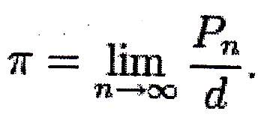
This limit converges because the more sides the polygon has, the closer the ratio approaches π. Archimedes determined the accuracy of π using a polygon with 96 sides and computed the fractional range: 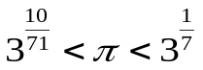 .
π can also be calculated using purely mathematical methods. Around 1400, Madhava of Sangamagrama found the first known series such as:
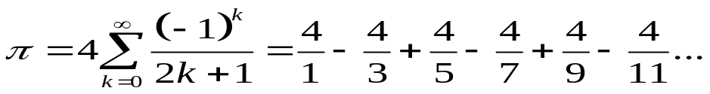
While that series is easy to write and calculate, it is not immediately obvious why it yields π. In addition, this series converges so slowly that nearly 300 terms are needed to calculate π correctly to 2 decimal places. This is now known as the Madhava-Leibnitz series or Gregory-Leibnitz series. However, by transforming this series into the form:
π 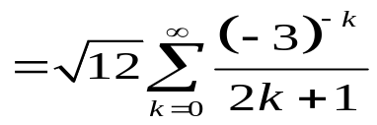
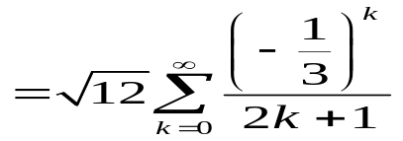
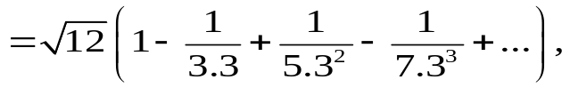
Madhava was able to estimate π as 3.14159265359, which is correct to 11 decimal places.
Around (1540-1610), the methods of calculus and determination of infinite series and products for geometrical quantities began to emerge in Europe. The first such representation was the Viète’s formula
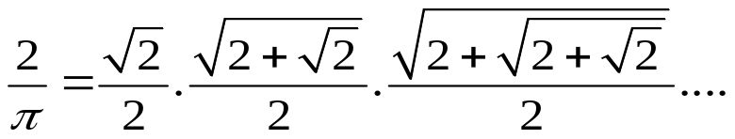
Another famous result is Wallis’ product:

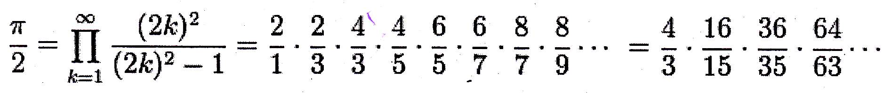
In 1735, Leonhard Euler solved the famous Basel- problem finding the exact value of

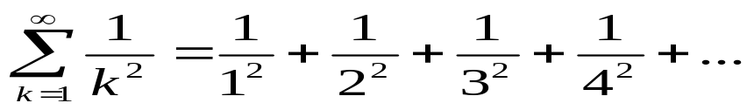
This is π²/6.
An important recent development was the Bailey-Borwein-Ploufee formula (BBP formula), discovered by Simon Plouffe and named after the authors of the paper in which the formula was first published, David H. Bailey, Peter Borwein, and Simon Plouffe. The formula,
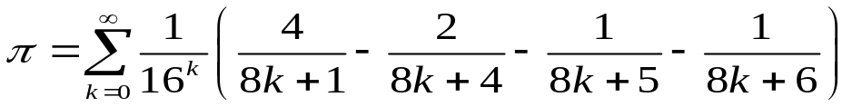
is remarkable because it allows extracting any individual hexadecimal or binary digit of π without calculating all the preceding ones. Between 1998 and 2000, the distributed computing project PiHex used a modification of the BBP formula due to Fabrice Bellard to compute the quadrillionth (1,000,000,000,000,000:th) bit of π which turned out to be 0.
In 2006, Simon Plouffe, using the integer relation algorithm PSLQ, found a series formulas:
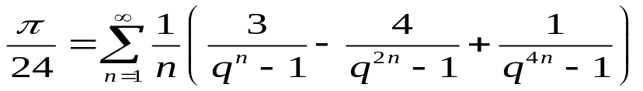

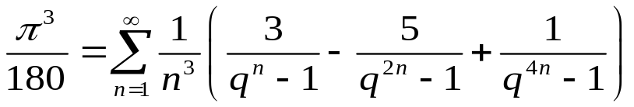
And others of form,
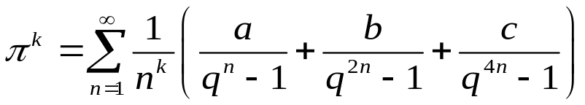
Where k is an odd number, and a, b, c, are rational numbers.
In the previous formula, if k is of the form 4m +3, then the formula has the particularly simple form,
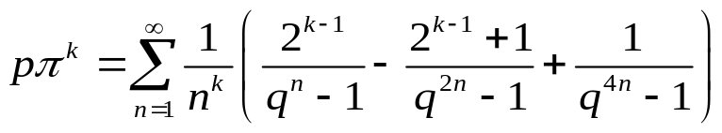
For some rational number p.

Pi and its continued fraction:
The sequence of partial denominators of the simple continued fraction of π does not show any obvious pattern:
π = [3; 7, 15, 1, 292, 1, 1, 1, 2, 1 3, 1, 14, 2, 1, 1, 2, 2, 2, 2, 1, 84,….]
Or
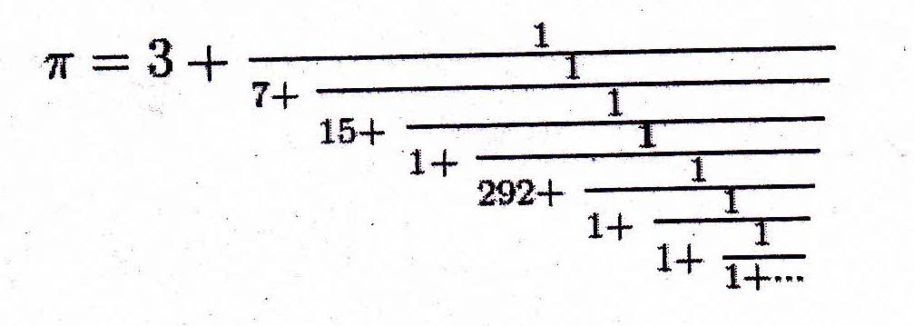
However, there are generalized continued fractions for π with a perfectly regular structure, such as:


